Astral Chronicles

–

The Fall of the Zodiac Pillars

Final Report

Table of Content:

Set up………..……………………………………………………………………..p

High Level Description.…………………………………………………………p

Pitch of the game....……………………………………………………….p

Backstory………..………………………………………………………...p

Level description..………………………………………………………...p

Boss specifications………………………………………………………...p

Events and Quests ………………………………………………………..p

Stages………………………………………………………………………………p

Characters…………………………………………………………………………p

Locations….……………………………………………………………………….p

Exterior cells...….………………………………………………………….p

Interior cells..………...…………………………………………………….p

Maps……………………………………………………………………………….p

Conversations……………………………………...……………….…………….p

Technical………....……………….………………………...……………………..p

Walkthrough………….……………………….…….…………………………….p

Description of assets.…………………….……………………………………….p

References…..……………………………….……………………………………..p

Set up:

The game needs only two things to run: the mod file, named ‘AstralChronicles.esp‘, and the save file that puts you at the beginning of the game, named ‘AstralChroniclesSave.ess‘. For the game to work properly you absolutely have to set the value “bBorderRegionsEnabled” to 0 instead of 1 in the oblivion.ini file or you will not be able to access the world map.

High Level Description:

Pitch of the game:

Astral Chronicles – The Fall of the Zodiac Pillars is the story about Eklektos, a man that is fated to save the world from its destruction. A cult known as the “Astral Clan” plans to use the power of the (soon to occur) planets conjunction to annihilate the human race.

The goal of the game is to defeat the “Zodiac Pillars”, the head members of the cult. They are the twelve priests at the head of the clan and each one is assigned to a zodiacal sign. They all have a particular weapon inspired by their assigned sign of the zodiac. When the Playable Character (here, Eklektos) defeat one, the priest will drop his weapon and the PC will have the possibility to use it as well. They are all in different locations across the map, and in different types of dungeons. They can be defeated in any order.

This is an action-adventure game set in a medieval fantasy world centred on battling enemies and exploring the world map.

Backstory:

Eklektos is an orphan found during a hunt in a forest when he was young, and because he doesn’t remember where he comes from he was adopted by the local villagers. Since his childhood, everybody in this village told Eklektos he was special, especially Aratus, who was the town’s astronomer. He was raised as a warrior and a hunter, but whenever he had spare time he always went to Aratus’s house to study the stars, the planets and the constellations. Aratus became like a father to him, taking care of him and teaching him all he knew. The day of his 25th birthday, Aratus offered him a beautiful sword and told him a story: He told him about a prophecy in which a hero would have to save the world from its destruction taking place during the planets conjunction, due to an evil cult. He also said that he believed that Eklektos was the man of the prophecy. However, the planets conjunction was planned to occur soon but nothing unusual seemed to be happening. Until a member of the Astral Clan killed Aratus because he knew too much. At this moment, Eklektos was certain he was the man of the prophecy. He knew he had to leave the village to save the world, and he swore to take his revenge by killing the members of the Astral Clan.

Level Description:

This is the beginning of the game. The PC, Eklektos, leaves his village to find and kill the four firsts priests: Orthar (the priest of Gemini), Basil (the priest of Sagittarius), Elena (the priest of Aquarius) and Kaminas (the priest of Aries). The PC will have 4 main quests, each one’s goal is to kill a different priest. In the real game, after defeating the four priests, the PC would have access to a new area with other priests to fight.

Boss specifications:

* Boss characteristics:

Aries: Mage with a fire staff.

Aquarius: Tank with an ice staff.

Sagittarius: Archer with electric arrows.

Gemini: Multiple bosses with a sword.

* Script for when you defeat a boss:

Defeat Aries: Aquarius health debuff and Sagittarius agility buff.

Defeat Aquarius: Sagittarius speed buff and one clone of Gemini will hunt you down.

Defeat Sagittarius: Aries attack buff and Gemini attack buff.

Defeat Gemini: Aries attack debuff and Aquarius attack buff.

* Scripts for the final boss:

When Aries is left: Big strength buff.

When Aquarius is left: Big health buff.

When Gemini is left: Big strength buff.

When Sagittarius is left: Attack speed and agility buff.

Events and quests:

* The game will start with the PC in his house in the village, he’ll go outside and talk to the people in the centre before leaving.
* By talking to the village’s leader, the PC will be assigned four quests.

1. Basil’s quest: defeat the priest of Sagittarius.
2. Kaminas’s quest: defeat the priest of Aries.
3. Elena’s quest: defeat the priest of Aquarius.
4. Orthar’s quest: defeat the priest of Gemini.

Those can be done in any order.

Stages:

**Quest 1: The Prophecy (EditorID: AAARobinDialogue)**

10 INT. Eklektos’s House (Village). *The Beginning*.

Set when: Player enters the cell “AAAGame” and collides with the activator “AAATRIGQUEST1”.

Eklektos starts his adventure in his house. Before leaving, he must take his sword.

Journal: Here we are… Now is the time to leave. I should take my sword.

20 EXT. Village. *Talking to the villagers*.

Set when: Player picks up the item “Eklektos’s Sword”.

Eklektos talk with the villagers. When talking with the village’s leader, he is assigned 4 more quests.

Journal: I need to speak to the village’s leader, maybe he’ll know where I should go.

30 EXT. Village. *Departure*.

Set when: Player selects the “Well, I'm leaving... Goodbye.” topic while talking to Robin.

Eklektos has the 4 quests and can leave the village.

Journal: I am now ready to go. (quest finished)

**Quest 2: Basil’s Quest (EditorID: AADefeatSagittarius)**

10 EXT. World Map. *Finding Basil’s location*.

Set when: Player selects the “Well, I'm leaving... Goodbye.” topic while talking to Robin.

Eklektos must head to the North to find the cathedral where Sagittarius stays.

Journal: I must find where the priest of Sagittarius is hiding.

20 EXT. World Map. *Finding another path*.

Set when: Player collides with the activator AATriggerBoxSagittarius near the cathedral fence.

Eklektos can’t enter the cathedral and must search for a secret entrance.

Journal: I found where Basil is hiding, but the cathedral is surrounded by a huge fence… I must search for another way to get in.

30 EXT. World Map. *Finding the tunnel*.

Set when: Player selects the “Well, I'm leaving. Thanks.” topic while talking to Michael.

Eklektos encounters Michael near the cathedral, and he indicates him where to find the secret entrance. He also tells him to defeat a monster for him in the graveyard, so he’ll give him the key to enter the cathedral.

Journal: Now that I met Michael, I must kill that monster. But first I must find the entrance…

40 EXT. World Map. *Finding the monster*.

Set when: Player gets in the cell “AASagittariusSewer”.

Eklektos finds the tunnel that goes to the graveyard and cathedral area.

Journal: Here’s the entrance, now I need to find and kill that monster.

60 EXT. World Map. *Collecting the key.*

Set when: Player defeats “AASkeleton” in the graveyard near the cathedral.

Eklektos meets with Michael again or for the first time and collects the key because he killed the monster.

Journal: I Defeated a big skeleton in the graveyard.

70 INT. Cathedral. *Kill Basil.*

Set when: Player receives the item “AASagittariusKey” when choosing the topic “ I killed a big skeleton.” while talking to Michael after stage 60.

Eklektos must defeat Basil to achieve the quest.

Journal: Now that I got the key, I can enter the cathedral and defeat Basil.

80 INT. Cathedral. *Basil’s Quest Completed.*

Set when: Player defeats “AABasilSagitarius”.

Eklektos defeated the priest of Sagittarius and completed the quest.

Journal: Basil Defeated (Quest finished).

**Quest 3: Kaminas’s Quest (EditorID: AADefeatAries)**

10 EXT. World Map. *Finding Leader’s friend.*

Set when: Player selects the “Well, I'm leaving... Goodbye.” topic while talking to Robin.

Eklektos must head to the South to find the Leader’s friend, Frederic, that’ll help him find the entrance.

Journal: I must find where Kaminas is hiding, and for that I must find Frederic.

20 EXT. World Map. *Finding the entrance.*

Set when: Player selects the topic “Well, I'm leaving. Thanks.” while talking to Frederic.

After meeting Frederic, Eklektos will head to the entrance of the dungeon.

Journal: Now that I spoke to Frederic, I must find the cave.

30 INT. Kaminas’s Dungeon. *Defeating the enemies.*

Set when: Player gets in the cell “AAAriesDungeon”.

Eklektos must make his way to the end of the dungeon.

Journal: This dungeon is full of those monsters! I must avenge Aratus… I MUST KILL THEM ALL!

40 INT. Kaminas’s Dungeon. *Defeating Kaminas.*

Set when: Player defeats the 3 trols, the 10 goblins and the minotaur accessible in the cell “AAAriesDungeon”

Eklektos must defeat the priest of Aries to finish the quest.

Journal: Now that all the enemies are dead, I must defeat Kaminas.

50 INT. Kaminas’s Dungeon. *Kaminas’s Quest Completed.*

Set when: Player defeats “AAAAries”.

Eklektos defeated Kaminas and completed the quest.

Journal: I defeated Kaminas (Quest finished).

**Quest 4: Elena’s Quest (EditorID: AADefeatAquarius)**

10 EXT. World Map*. Finding Elena’s location.*

Set when: Player selects the “Well, I'm leaving... Goodbye.” topic while talking to Robin.

Eklektos must head to the West to find the island where Elena stays.

Journal: I must find where Elena is hiding.

20 EXT. World Map. *Finding the key.*

Set when: Player collides with the activator “AATriggerBoxDoorAquarius” on Elena’s dungeon entrance door.

The door to Elena’s dungeon is locked and Eklektos needs a key to enter.

Journal: The door is locked… I should search for the key, it shouldn’t be too far away.

30 EXT. World Map. *Entering the dungeon.*

Set when: Player finds the key “AAAquariusKey” in a box in the lake.

Eklektos found the key in a chest and heads back to the dungeon.

Journal: I finally found that damn key! Now I can open the door.

40 INT. Elena’s Dungeon. *Kill Elena.*

Set when: Player gets in the cell “AAAquariusDungeon”.

Eklektos entered the dungeon and must go through it to find and defeat Elena.

Journal: I must go through dungeon and make Elena pay.

50 INT. Elena’s Dungeon. *Elena’s Quest Completed.*

Set when: Player defeats “AAAquarius”.

Eklektos defeated Elena and completed the quest.

Journal: I have defeated Elena.(Quest finished)

**Quest 5: Orthar’s Quest (EditorID: AADefeatGemini)**

10 EXT. World Map. *Finding Orthar’s location.*

Set when: Player selects the “Well, I'm leaving... Goodbye.” topic while talking to Robin.

Eklektos must head to the East of the world map to find the ruins where Orthar stays.

Journal: I must find where Orthar is hiding.

20 EXT. World Map. *Prepared for combat.*

Set when: Player selects the “Well, I'm leaving.Thanks and goodbye.” topic while talking to Harry.

Eklektos met a friendly adventurer named Harry outside that told him some information about Orthar. He is now ready to enter the dungeon.

Journal: I found Harry and he told me precious information about the priest of Gemini. I am now prepared to go and defeat him.

30 INT. Orthar’s Dungeon. *Getting through the maze and killing Orthar.*

Set when: Player gets in the cell “AAAGeminiDungeon”.

Eklektos entered the dungeon and must find Orthar to kill him.

Journal: I entered the dungeon. I must find and kill Orthar.

35 INT. Orthar’s Dungeon. *Job half done.*

Set when: Player defeats “AAOrtharGemini1” or “AAOrtharGemini2”

Eklektos defeated one of the two Orthar’s twin.

Journal: I have killed one of the Orthar twins.

40 INT. Orthar’s Dungeon. *Orthar’s Quest Completed.*

Set when: Player defeats the second Gemini twin

Eklektos defeated Orthar and completed the quest.

Journal: I have defeated Orthar.(Quest finished)

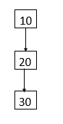

Quest 1 Stage Flowchart:

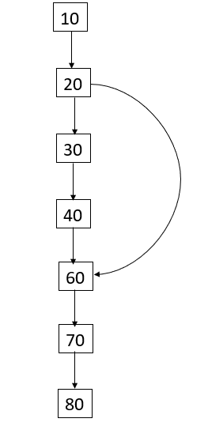

Quest 2 Stage Flowchart:

Quest 3 Stage Flowchart: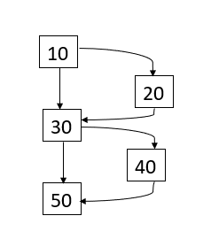

Quest 4 Stage Flowchart: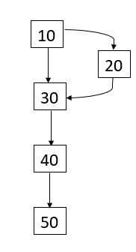

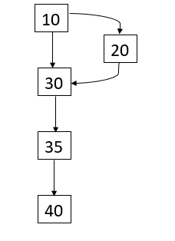

Quest 5 Stage Flowchart:

Characters:

All of the characters have been created from scratch in the NPC editor of the construction set. They are not based on any Oblivion NPC and the face have been generated manually. Their clothes (and weapon) have been chosen to fit their appearance, personality and their role in the game.

Eklektos :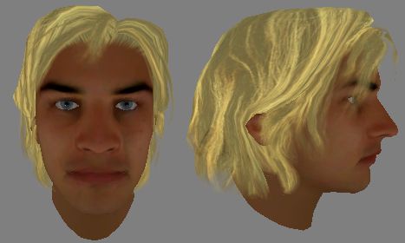

Eklektos is the Playable Character of the game. His quest is to defeat the Zodiac Pillars.

Robin : (EditorID: AALeaderRobin)

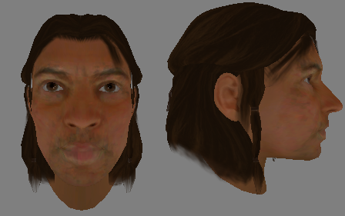

Robin is the village’s leader. He wishes good luck to Eklektos as he leaves and assign to him the quests to defeat each priest.

Location: Village.

Villager Anna : (EditorID: AAVillagerAnna)

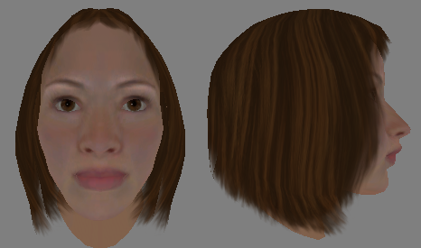

Anna is a villager and friend of Eklektos. She wishes him good luck as he leaves.

Location: Village.

Villager Stephan : (EditorID: AAVillagerStephan)

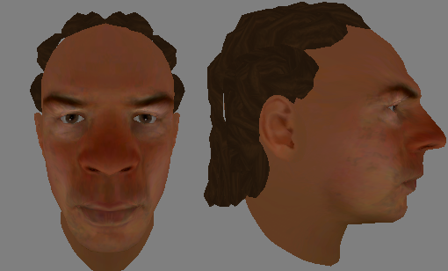

Stephan is the best hunter in the village and a friend of Eklektos. He wishes him good luck as he leaves.

Location: Village.

Leader’s Friend Michael : (EditorID: AAMichael)

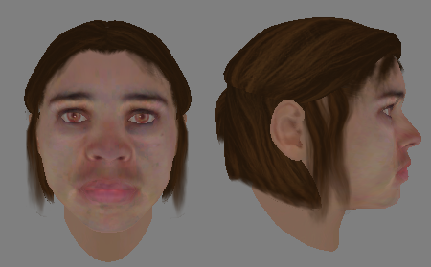

Michael is Robin’s friend and a NPC helping Eklektos during his quest to defeat Sagittarius. He indicates him the location of a secret entrance for the cathedral and gives him a key if he kills a specific monster.

Location: In the Rock Plains near the Cathedral (Basil’s Dungeon)

Leader’s Friend Frederic : (EditorID: AALeaderFriendFrederic)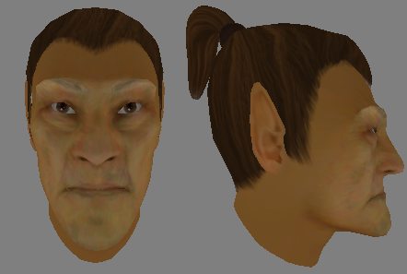

Frederic is Robin’s friend and a NPC helping Eklektos during his quest to defeat the priest of Aries. He indicates him the location of the entrance for the cave and gives him information about the priest.

Location: Near Kaminas’s dungeon entrance.

Adventurer Harry : (EditorID: AAADventurerHarry)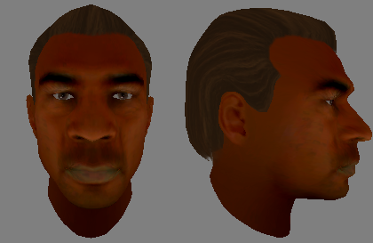

Harry is an adventurer NPC helping Eklektos during his quest to defeat the priest of Gemini. He indicates him the location of the entrance for the cave and gives him information about the priest.

Location: Ruins near Orthar’s dungeon entrance.

Elena, priest of Aquarius : (EditorID: AAAquarius)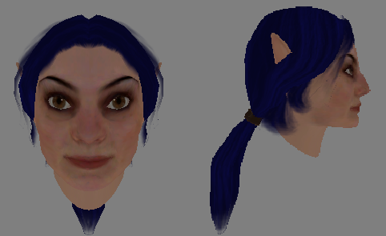

Elena is one of the Zodiac Pillars. She is a water-ice mage with a staff.

She was a tactician before joining the cult, so she resides in a dungeon full of traps.

Location: Elena’s dungeon.

Orthar, priest of Gemini: (EditorIDs: AAOrtharGemini1 & AAOrtharGemini2)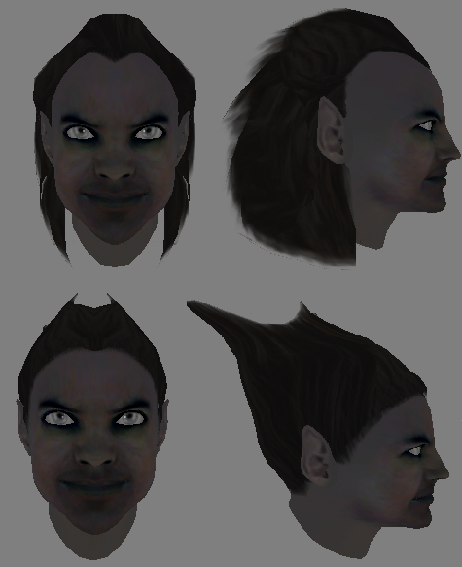

Orthar is one of the Zodiac Pillars. He is a two-boss in one, with a melee weapon.

He always has been schizophrenic, until one day he divided into two.

Location: Orthar’s dungeon.

Kaminas, priest of Aries: (EditorID: AAAAries)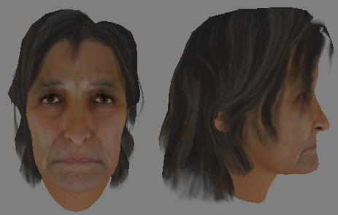

Aries is one of the Zodiac Pillars. She is a fire mage with destructive spells.

She is the oldest member of the cult.

Location: Kaminas’s dungeon.

Basil, priest of Sagittarius: (EditorID: AABasilSagitarius)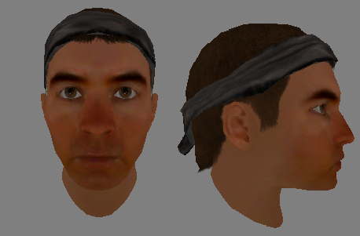

Basil is one of the Zodiac Pillars. He is a very skilled archer with some electric arrows.

He is the youngest member of the Zodiac Pillars

Location: Cathedral (Basil’s dungeon

Locations:

Exterior cells:

The outside playable area has been created manually via the ‘landscape editor’ tool of the construction set. It has been made modifying the height and textures of the underwater wilderness cells in Tamriel, around the location (-62, -18). Here is the list of the exterior cells used for the map.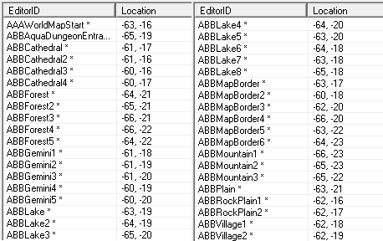

Interior cells:

Eklektos’s House (EditorID: AAAAHouse): where the game begins, where the PC is loaded from the ‘set up’ save.

Eklektos’s House - Cave (EditorID: AAAGame): the first quest is assigned to the PC when he first enters the room. This cell is linked to AAAAHouse via a door and to the exterior (ABBVillage1) via another one.

The two cells of Eklektos’s house have been created by duplicating the cell ‘ChorrolTheOakandCrosierCelllar’, removing all the current objects, renaming the cell and adding new objects with the object window.

Aquarius’s Dungeon (EditorID: AAAquariusDungeon): One of the four dungeons that you must complete to complete the quest. 100% made from scratch using the Construction Set with no imports. It consists of a walls from the “cave” tabs in the object tab, a variety of traps, the boss NPC, Aquarius, mudcrabs from creatures tab and miscellanies objects such as barrels planks for aesthetics. It has a crevices and barricades to vary the player’s path of choice. From the traps and triggers directory there are trip wires mostly, several trigger plates and platforms that can be activated by walking on them.

Maps:

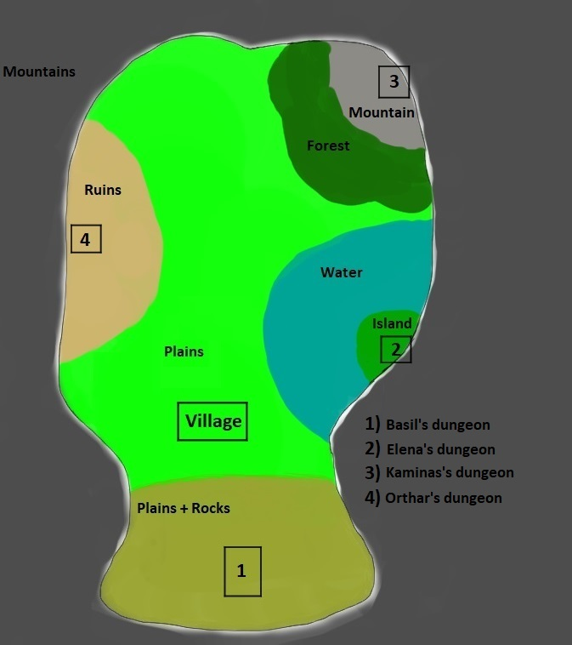

World map:

Village:

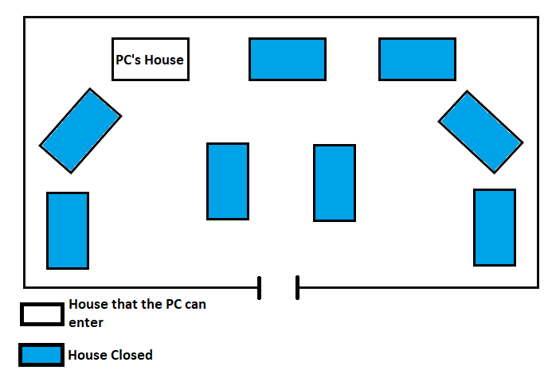

Orthar’s Dungeon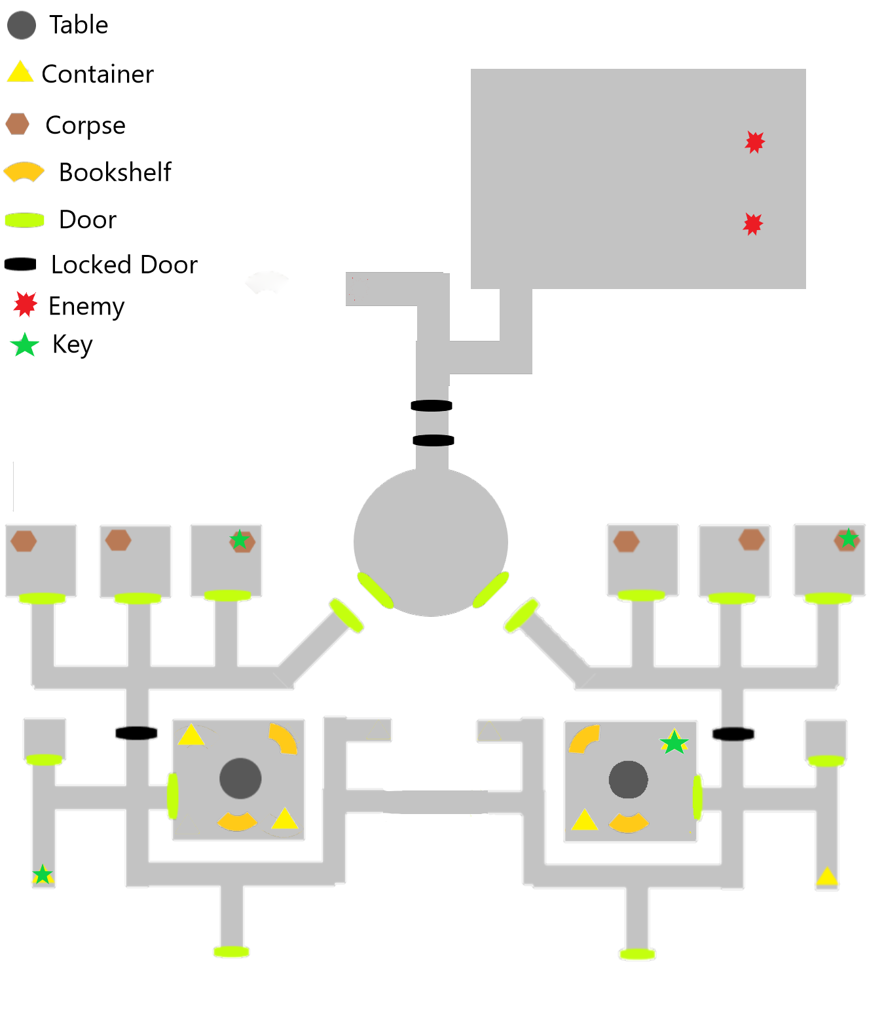

Conversations:

Anna (EditorID: AAAAnnaDialogue) :

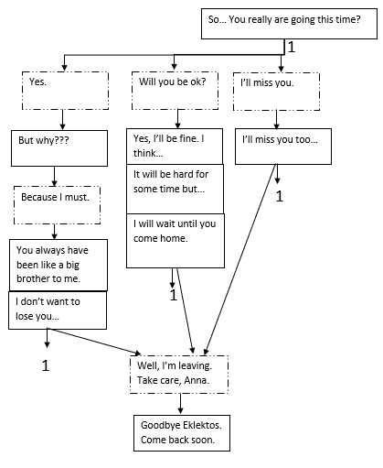

Robin (EditorID: AAARobinDialogue):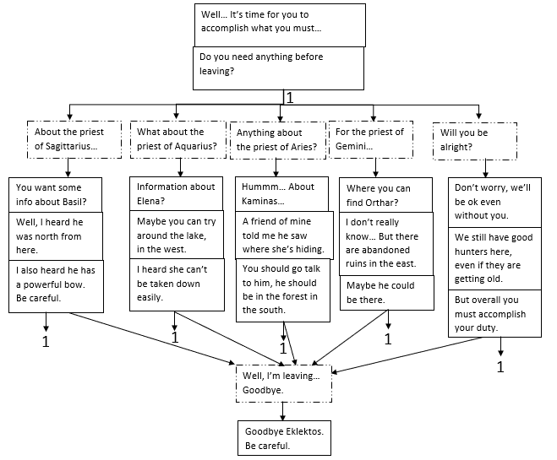

Stephan (EditorID: AAAStephanDialogue):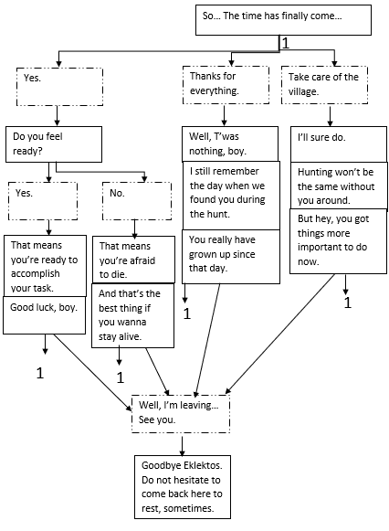

Frederic (EditorID: AAFredericQuest):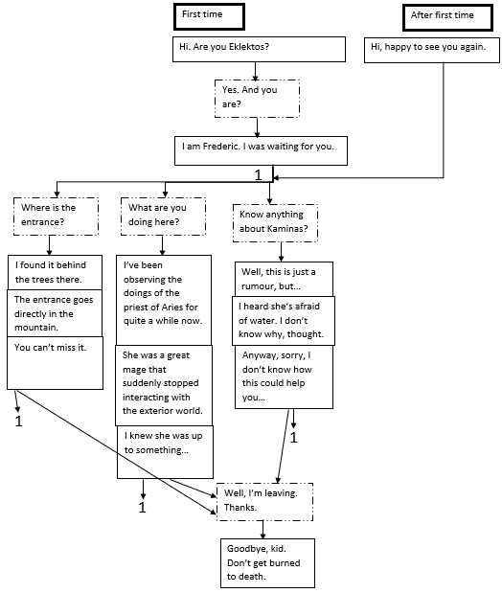

Harry (EditorID: AAHarryQuest):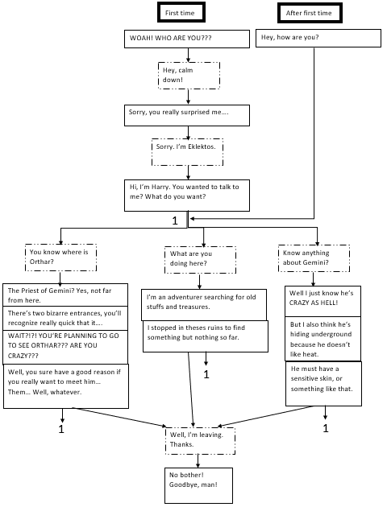

Michael (EditorID: AAMichaelQuest):

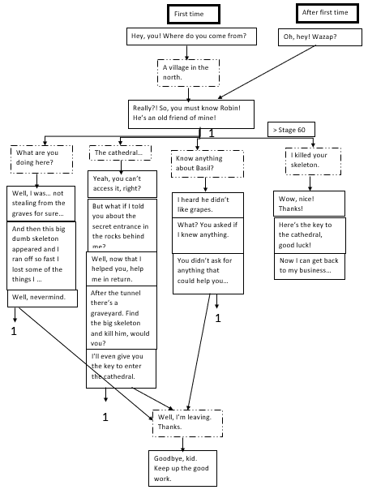

Technical:

The group treating the game counting 5 member, the work has been divided in five: One assigned to the world map and the village, and the others each assigned to a dungeon, each one having a different mod to work on. In the early stages of the game creation, everybody worked on his own mod and they all were put together onto the same mod for the meetings, so the PC could get from the world map to the different interiors of the game without having to swap between mods. Since several week the whole group shares the same mod file, allowing only one person to be able to modify it at a time, but preventing the errors and mismatches that could happen when putting the mods together.

We made a group chat over FaceBook, to exchange different the 20 versions of our mod , for convenience and to arrange meetings. We all had a version of Oblivion on our laptops so everyone was able to work on their part of the mod at any time. Along with that we did work side by side to help each multiple times as it’s easier in person. Dealing with NPCs took time and effort with the Construction Set.

Walkthrough:

Quest 1: The Beggining.

The game starts with Eklektos being in the cave of his house.

The first thing you need to do is to go out by the door.

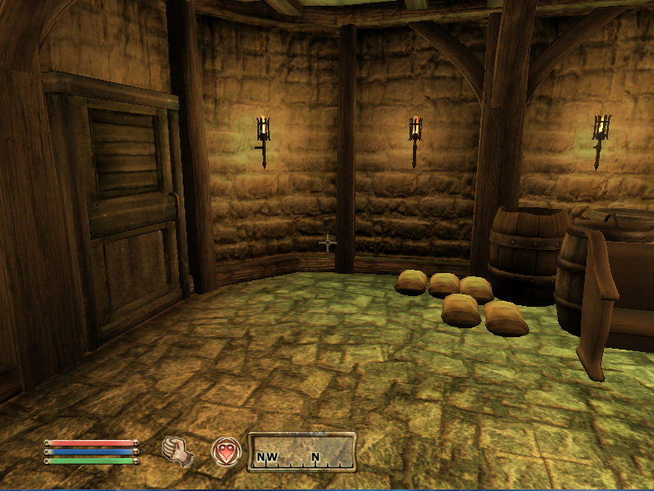

Once you arrive in the main room of the house you are assigned a new quest, where you need to pick up your sword.

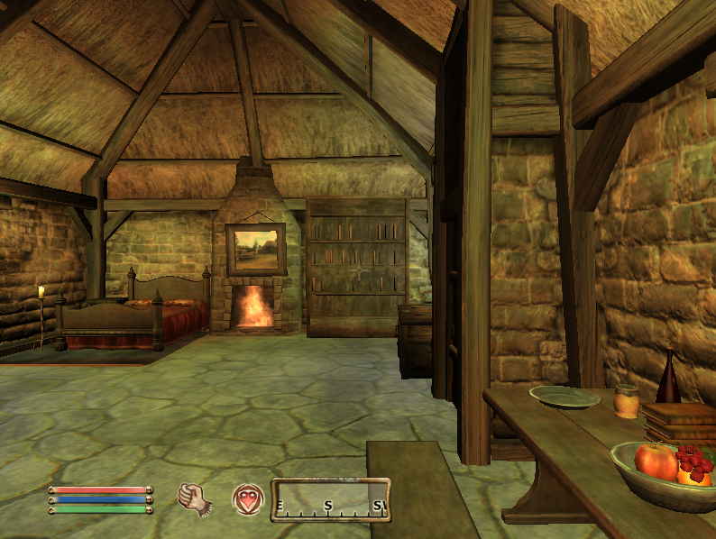

It can be found in a chest near the other door of the room.

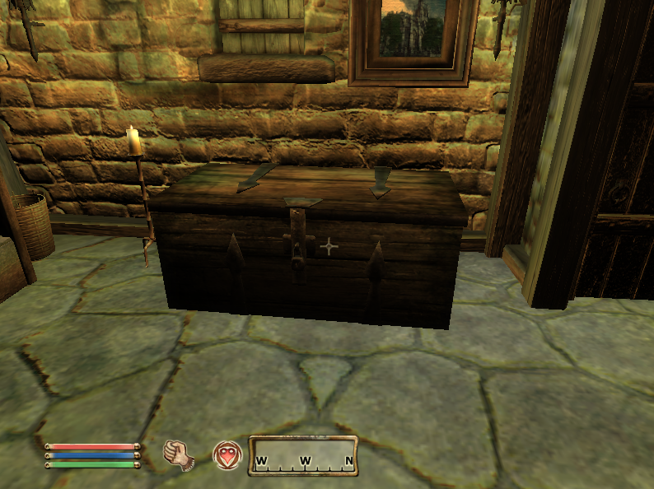

Once you pick up the weapon, you are ready to go out. Take the exterior door and go to the left to talk to the NPCs.

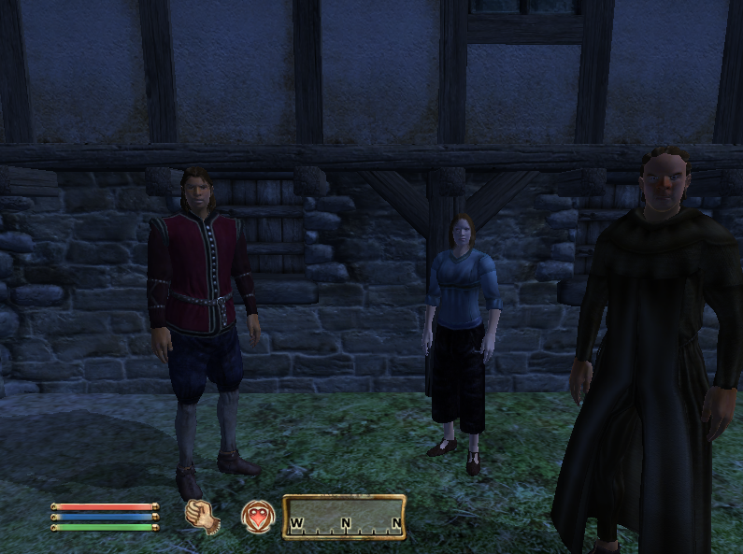

While talking with Robin, you can acquire information on when to find each priest. When you finish talking to him, you finish the first quest.

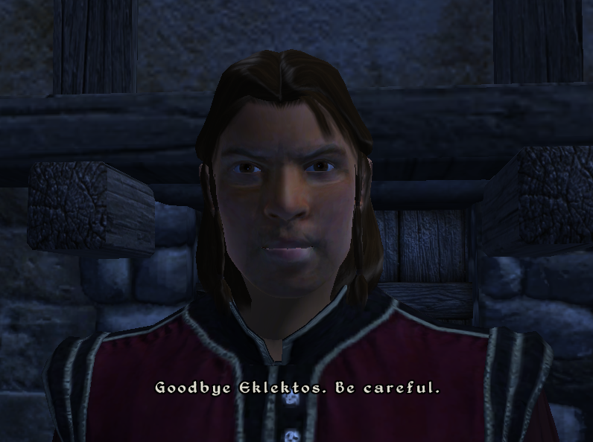

End of Quest 1.

Quest 5: Orthar’s Quest

*Gemini’s Maze:*

The maze’s structure is as follows:

It can be entered through either of the two bottom doors in the image. Once entered, the player must find their way through the maze by finding the keys and unlocking the doors in order to find the Gemini boss. There are multiple paths through this maze and, if done right, can be completed by only unlocking 3 of the 4 doors. The only information needed to complete the dungeon efficiently, is knowing where the keys are and what doors they go to.

The following image depicts this information:

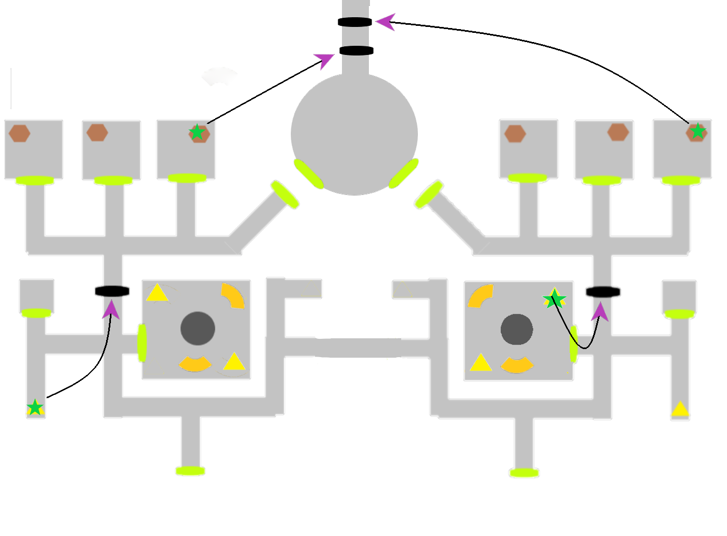

The only tricky part is that the bottom-right key (if looking at the map from the top-down) is actually located in the bottom-right box (if looking at the stack of 3 boxes from the perspective of the table in the room).

Once all the doors are unlocked, it is only necessary to defeat the 2 bosses in the final room.

End of Quest 5.

Description of assets:

References: